# Who can Afford to Fail? Art and Risk in an Era of Precarity

### Grace McQuilten

Failure is often associated with risk taking and an entrepreneurial spirit, indelibly linked with the ruptures and expansions of contemporary capitalism. As Slavoj Žižek writes, ‘capitalism, which can survive only by incessantly revolutionising its own material conditions, ceases to exist if it “stays the same,” if it achieves an internal balance’.[1] Like other aspects of capitalism, the opportunity to take risks and fail is not equally distributed; who can afford to fail?

In the arts, a healthy tolerance for failure is set against a backdrop of increasing institutional managerialism, risk management, and conservative curation that prevents failure before it has the opportunity to take a breath. This is particularly evident in institutions such as art museums. As Frances Ryan argues:

Museums operating as first modernity institutions that seek to control risk parameters concentrate on the collective and governable audience through directing conversations and limiting boundaries and base many of their curatorial decisions with their target demographic audience in mind.[2]

A counter-interest in conceptual, unrealizable projects like *Unbuilt America* provides a ‘safe’ ground for artists and curators to explore failure — without true risk.[3] In parallel to the safe risk-taking of art galleries and museums, individual artists and independent-run spaces operate in such highly unpredictable, precarious conditions that the reality of failure is a constant drum-beat that tests the very possibility of making an art project, let alone a living (Raunig 2011). How much can we ask people to contribute — both in a human capacity and through income — to realize a risky project, and risk failure?

This chapter engages with this central tension between risk and failure through a reflection on my curatorial responsibilities across two very different and ambitious projects: *Remote-Controlled Terrorist Coffin* (2015) by US artist/architect Adam Kalkin and *The Magic Tent* (2011), a community building public art project by The Social Studio. Both projects brought the excitement and transformative potential of embracing both risk and potential failure. On the flipside, both projects brought to bear the potential costs and human impacts when projects fail, both mildly and spectacularly. In the context of the power structures of contemporary capitalism, these challenges raise a central question: is failure a privilege of those who have the resources and capacity to fail?

## Adam Kalkin: *Remote-Controlled Terrorist Coffin*

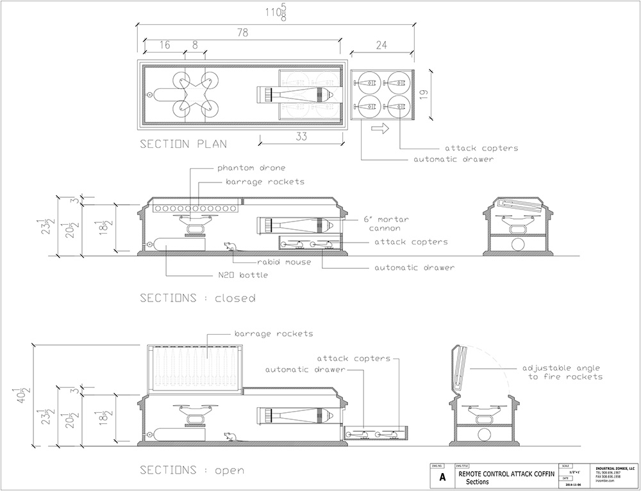

Figure 16.1: Adam Kalkin, *Remote Controlled Terrorist Coffin Sketches*, 2015*.* Courtesy of the artist.

In 2015 I collaborated with New Jersey-based artist and architect Adan Kalkin to bring to life a complex and ethically high-risk project: *Remote-Controlled Terrorist Coffin* (*RCTC*) — a coffin engineered with a variety of weapons that could be remote-controlled via the internet. Kalkin was interested in the unregulated development of new technologies with potential application in military conflict — for example, drones — and questions related to the ethics of design. The artist collaborated with engineer Aaron-Ray Chrichton to reverse-engineer consumer products readily available on the market, including hobby drones and pyrotechnic equipment.

It was my task to organize the shipping of the coffin and associated technologies from the USA to Australia, and then make the artwork available to audiences. We developed the work as an independent project and proposed it for an exhibition at Project Space/Spare Room Galleries, a small arts space for experimental works at RMIT University in Melbourne. Here unfolded an extraordinary complex dance with bureaucracy, common sense, risk management forms, ethical questions, and, inevitably, compromise with the distinct taste of failure.

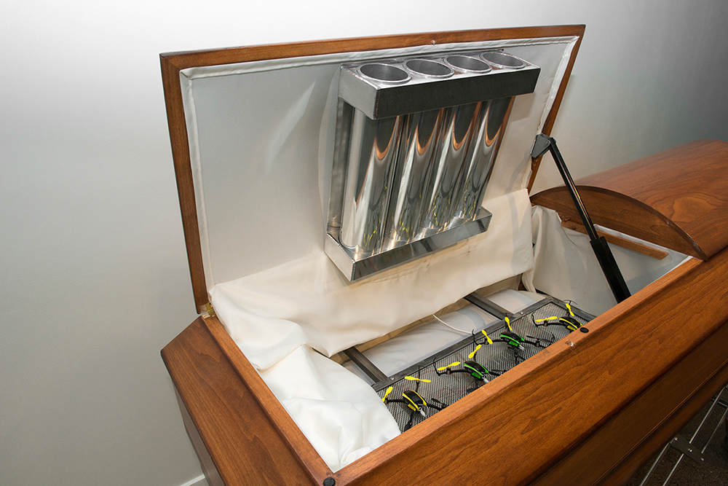

Figure 16.2: Adam Kalkin, *Remote Controlled Terrorist Coffin*, installation view, RMIT Project Space/Spare Room Galleries. Courtesy RMIT Culture.

Project Space/Spare Room Galleries are located on Swanston Street in Carlton, on the edge of Melbourne’s CBD, with a shopfront that engages audiences including University staff and students and general passers-by. For the exhibition, we set up the gallery to look like a funeral viewing: rows of bench seats lined up to face the centrepiece of the show, the radically re-engineered coffin, which at first glance looked like a quite traditional wood panelled coffin. It was resting on a waist-height trolley. The coffin was fitted with an automatically opening/closing compartment at the base and an automatically opening/closing half-door on top. Audiences who were unaware of these components would be startled when it randomly opened, stayed open for a time, and then randomly closed again. Inside, the coffin was fitted with a range of both conventional and unconventional ‘weapons’ sourced from the consumer market — including a spy drone, a large bore mortar cannon, a truth gas dispersion unit, an attack helicopter squadron, cyber coercion technology, and an innovative bio-pestilence feature. The coffin was accompanied by an instructional video for its potential use, which included the artist testing its different capacities, including firing a cannon on location in New Jersey.

The first moment of potential failure for this project involved getting the work through customs: miraculously, and perhaps concerningly, it did make it through customs, although not without being stopped and tagged before release. The gallery had an anxious wait with no Plan B if the work was held indefinitely, or indeed returned to the artist. The next issue was establishing what components of the coffin could be fully operational within the setting of a gallery.

This is where the compromises began.

While the work was meant to be fitted with a range of different chemical and mechanical components, in reality the only way that occupational health and safety (OH&S) staff would allow the work to be on display was through the de-activation of these components. The canister of nitrous oxide was empty. The more explosive part — a cannon that fires — was similarly present only in a symbolic and entirely non-operational form. Was this a failure of risk and artistic conviction? Yes, it probably was. On the other hand, the potential for harm to the public, although extremely minimal, caused significant distress for the technical and gallery staff involved. At what point is the ambition that comes with a risky project like RCTC worth the emotional toll it takes on those involved?

Other parts of the work were more successful. The artist and engineer were able to operate the coffin by remote-control from the USA, including unleashing the helicopter drones within. Despite the ominous sounding title of the work, in effect, the coffin was both absurd and comical. The idea of a coffin that unleashes laughing gas or a squadron of ‘attack helicopters’ that were smaller than the size of a hand was ridiculous. As Kalkin himself explained at the time:

A lot of the stuff I do is narrative, ‘what if?’ propositions. What if I were a terrorist? I’m not even sure that’s the proposition [… ] [but] I was thinking a lot about terrorism and this do-it-yourself entrepreneurial spirit that these kinds of people have.[4]

And yet despite the obvious absurdity — and the impossibility of the work being activated for malintent — the artwork and art project nevertheless caused high degrees of anxiety across the university. What this revealed was that the idea of ‘terror’ in and of itself elicits terror. The exhibition was held more than a decade after the 9/11 attacks in the USA, and yet the psychological and ideological ‘war on terror’ was continuing. The issues around risk, critique, and censorship came to a head when the gallery prepared a media release for the exhibition; a media release that was never to be released.

Despite the internal challenges of presenting and promoting a show dealing with issues of terror, war, and the design of military weapons, a nuanced public program opened up a space to carefully and critically explore this terrain. The program brought together academics, designers, artists, and the public. The RCTC raised important questions about the role of design in the emergence of military technologies, big data, surveillance, privacy, freedom of movement in public space, regulation of technology, terrorism, and the potential risks posed by the social ‘outsider’ with access to the internet. It also traced a line from games to warfare in consumer society. However, without a significant appetite for risk, from the artist to the gallery and technical staff, the project would never have been realized — and what was realized, in the end, was compromised.

## *The Magic Tent*

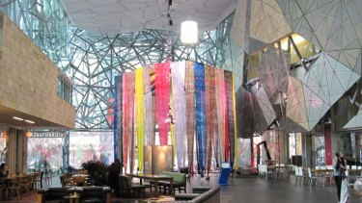

Figure 16.3: The Social Studio, *The Magic Tent*, Federation Square, Melbourne, 2011. Courtesy The Social Studio.

The second project that forms the critical reflection for this chapter involved a radically different set of ethics, possibilities, and challenges. *The Magic Tent* was a public art project presented by The Social Studio, a non-profit social enterprise in Melbourne, Australia that brings together art, fashion, and design to create training and employment for young creatives from refugee and migrant backgrounds. I worked with the team at The Social Studio to produce *The Magic Tent* for the Craft Cubed Festival and Melbourne Spring Fashion Week in September 2011. It involved a 14-square metre tent-like structure suspended from the atrium of Federation Square in Melbourne’s CBD. The tent was made entirely of 600 metres of hand-dyed silk; the beautiful and gentle swaying fabric created an ethereal effect.

Once installed, *The Magic Tent* became a community art, craft, and design studio where emerging artists from The Social Studio and its community of creatives became teachers. ‘Super Maker’ workshops were offered that enabled artists to share their skills in sewing, jewellery design, weaving, fabric dyeing, traditional tailoring, and draping. The project aimed to bring visibility to the talents of emerging artists while addressing public perceptions about issues of migration and displacement through asserting the value of cultural and creative difference. Over the space of two and half weeks, *The Magic Tent* became a creative hub that featured learning, knowledge exchange, social gathering, and performance and brought art into the public domain. At the end of the August, the hand-dyed silk fabric that composed the tent was deconstructed and repurposed into The Social Studio’s Spring Fashion Collection; enabling the tent to have a long life both physically and symbolically.

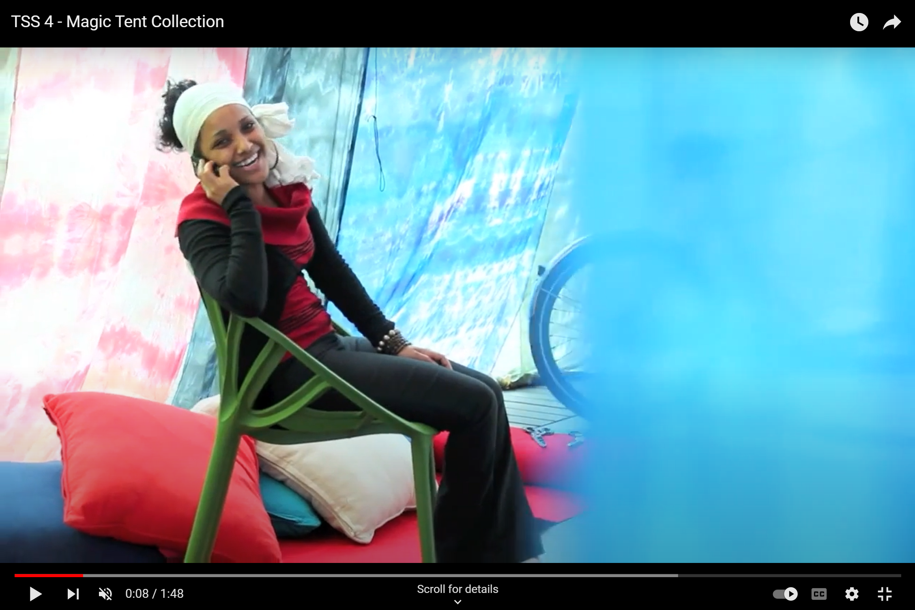

Figure 16.4: Artist Almaz Gebru inside *The Magic Tent*, 2011. Courtesy The Social Studio.

While there was so much to love about this project, it also involved a high degree of financial, personal, and interpersonal risk. With only minimal funding secured to realize the ambitious project, staff at The Social Studio had to work above and beyond their limits to achieve the scale required. Hand-dyeing 600 metres of silk fabric required not only a significant amount of time and manual labor, but also space — for weeks the studio spaces at The Social Studio were overtaken and blanketed by metres upon metres of silk fabric, interrupting usual patterns, teaching, and other material requirements for the staff, students, and visitors to the space. There were points in time where it seemed the scale was simply unachievable. But the greatest risk of all came at the time of installing *The Magic Tent*. A team of riggers were contracted to help install it overnight at the Atrium. However, it wasn’t until the team arrived that the full reality and complexity of the project struck. Not only did the lengths of fabric need to be carefully hoisted (silk is a relatively fragile material) over the supporting beams, but the design plans as drafted did not meet the structural reality of the atrium space.

A re-design was required in-situ, along with an enormous amount of hand-sewing on the spot, to enable the lengths of fabric to fit to the size of the atrium beams. Failure danced with *The Magic Tent* that night. It was an extremely long night for the team involved in installing the work, and the only thing that stood between success and failure was the individual persistence of one staff member who stayed through the night to make it work. This involved a kind of physical and emotional labor that can’t be captured in a project plan, and that couldn’t be properly renumerated in dollar terms.

The final result, *The Magic Tent,* was powerful, magical, ethereal, and moving. And yet, I can’t help but ask myself a number of questions arising from the process. Was the stress involved for the Social Studio team — those weeks of dying fabric by hand and upending the school and studio activities, and that gruelling night of extremely high stakes and low reward — was it truly worth the benefits that came in the final creative product, a work that was only in public for a few short weeks? What would have been the impact on creativity and morale if the work had failed to be installed that night — a reality we came so very close to? It is one thing to take on personal risk; another to transfer that risk to a team of collaborators who may or may not have financial and personal resources required to withstand the impacts of failure. And finally, who might not be able to take on these kinds of risks?

## Conclusion

Artists who are already struggling with the precarity of making a living — the norm is to live well under the poverty line — and with the stress and responsibilities of self-employment, are much less likely to risk failure than galleries and institutions with more financial and human capital.[5] And yet if large scale and risky projects are left entirely to larger institutions to realize, then it is extremely unlikely that projects like *Remote Controlled Terrorist Coffin* or *The Magic Tent* would ever have happened. Without such individual and community-led ambitious and bold ideas — what Gregory Sholette describes as the ‘dark matter’ of the art world — then the art sector continues to repeat its own motifs to a small and narrow audience.[6]

However, to cultivate creative risk and support independent artists’ agency requires enormous effort with little funding and support — the paradox of the *independent project*. As the economic and social crises of the arts continue to deepen in the wake of the COVID-19 pandemic, the scope for entrepreneurialism, risk-taking, and failure increasingly narrows for individual artists and independent artist-run spaces. Yet risk and failure in the arts are needed now perhaps more than ever.

## Bibliography

Rainforth, Dylan. ‘Artist Builds Missile-Decorated ‘Terrorist Coffin’’, *The Age*, February 22 2015, https://www.smh.com.au/entertainment/art-and-design/artist-builds-missiledecorated-terrorist-coffin-20150223-13leub.html

Raunig, Gerald, Ray, Gene, and Wuggenig, Ulf (eds). *Critique of Creativity: Precarity, Subjectivity and Resistance in the 'Creative Industries'*, London: MayFly Books, 2011.

Ryan, Frances. ‘Australian Museums in the ‘Age of Risk’: A Case Study’, in *Museum Management and Curatorship* 32.4 (2017): 372—394, 381, https://doi.org/10.1080/09647775.2017.1345647.

Sholette, Gregory. *Dark Matter: Art And Politics in the Age of Enterprise Culture*, London: Pluto Press, 2011.

Sky, Alison and Stone, Michelle. *Unbuilt America: Forgotten Architecture in the United States From Thomas Jefferson to the Space Age: A Book*, New York: McGraw-Hill, 1976.

Žižek, Slavoj. *The Sublime Object Of Ideology*, London: Verso, 2008 [1989].

1. Slavoj Žižek, *The Sublime Object Of Ideology*, London: Verso, 2008 [1989], 52
2. Frances Ryan, ‘Australian Museums in the ‘Age of Risk’: A Case Study’, in *Museum Management and Curatorship* 32.4 (2017): 372—394, 381, https://doi.org/10.1080/09647775.2017.1345647.
3. Alison Sky and Michelle Stone, *Unbuilt America: Forgotten Architecture in the United States From Thomas Jefferson to the Space Age: A Book*, New York: McGraw-Hill, 1976.
4. Adam Kalkin, cited in Dylan Rainforth, ‘Artist Builds Missile-Decorated ‘Terrorist Coffin’’, *The Age*, February 22 2015, https://www.smh.com.au/entertainment/art-and-design/artist-builds-missiledecorated-terrorist-coffin-20150223-13leub.html
5. Gerald Raunig, Gene Ray, and Ulf Wuggenig (eds), *Critique of Creativity: Precarity, Subjectivity and Resistance in the 'Creative Industries'*, London: MayFly Books, 2011.
6. Gregory Sholette, *Dark Matter: Art and Politics in the Age of Enterprise Culture*, London: Pluto Press, 2011.